ETL Using Glue

-- Inserting into country dimension

SELECT DISTINCT country AS country_name FROM movie_details;

--Inserting into movie dimension

SELECT

imdb_id,

title,

language,

CASE

WHEN adult = 'False' THEN 0

WHEN adult = 'True' THEN 1

END AS adult

FROM movie_details;

--Inserting into date dimension

SELECT

release_date,

YEAR(release_date) as year,

MONTH(release_date) as month,

DAY(release_date) as day

FROM movie_details

where release_date != '';

--Inserting into genre dimension

SELECT DISTINCT genres AS genre_name FROM movie_details;

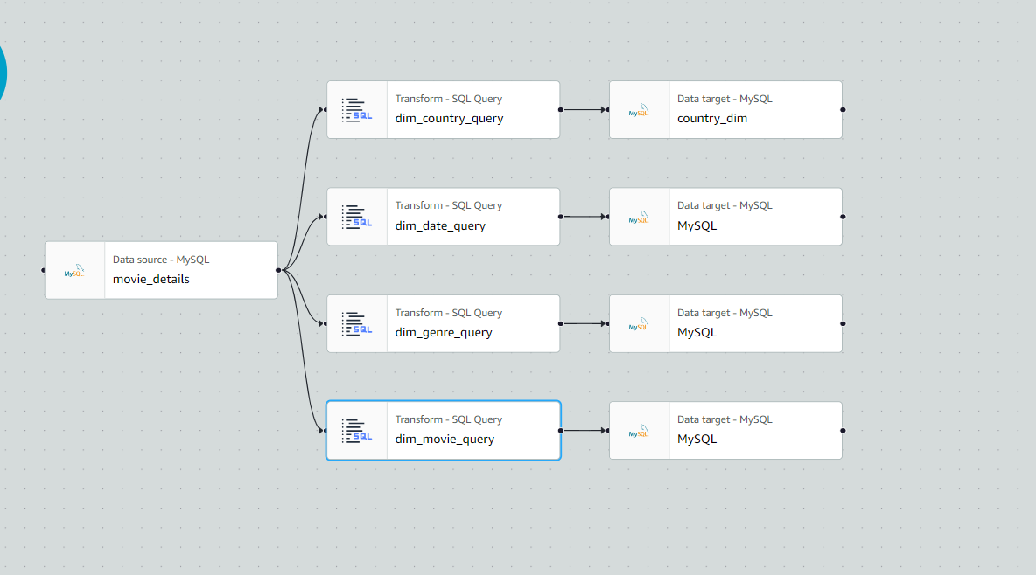

--Inserting into movie fact table

SELECT distinct

dm.movie_id as movie_id

, dd.date_id as date_id, dg.genre_id as genre_id, dc.country_id as country_id,

m.budget as budget, m.revenue as revenue, m.runtime as runtime, m.popularity as popularity,

m.avg_rating as avg_rating, m.people_rated as people_rated

FROM movie_details as m

JOIN movie_dim as dm ON m.imdb_id = dm.imdb_id

JOIN date_dim as dd ON m.release_date = dd.release_date

JOIN genre_dim as dg ON m.genres = dg.genre_name

JOIN country_dim as dc ON m.country = dc.country_name

where m.release_date != '';

